**Walchand College of Engineering, Sangli**

**Department of Computer Science and Engineering**

**Semester: 1**

**Class: Final Year (Computer Science and Engineering)**

**Year: 2022-23**

Course: High Performance Computing Lab

Name: Sakshi Sanjay Desai

Prn No.2019BTECS00021

Batch:B1

**Practical No. 5**

**Installation of MPI and implementation of basic functions of MPI**

Complete the installation of MPI on the platform chosen by you.

Installing MPI in local machine

Installed using command : sudo apt install mpich

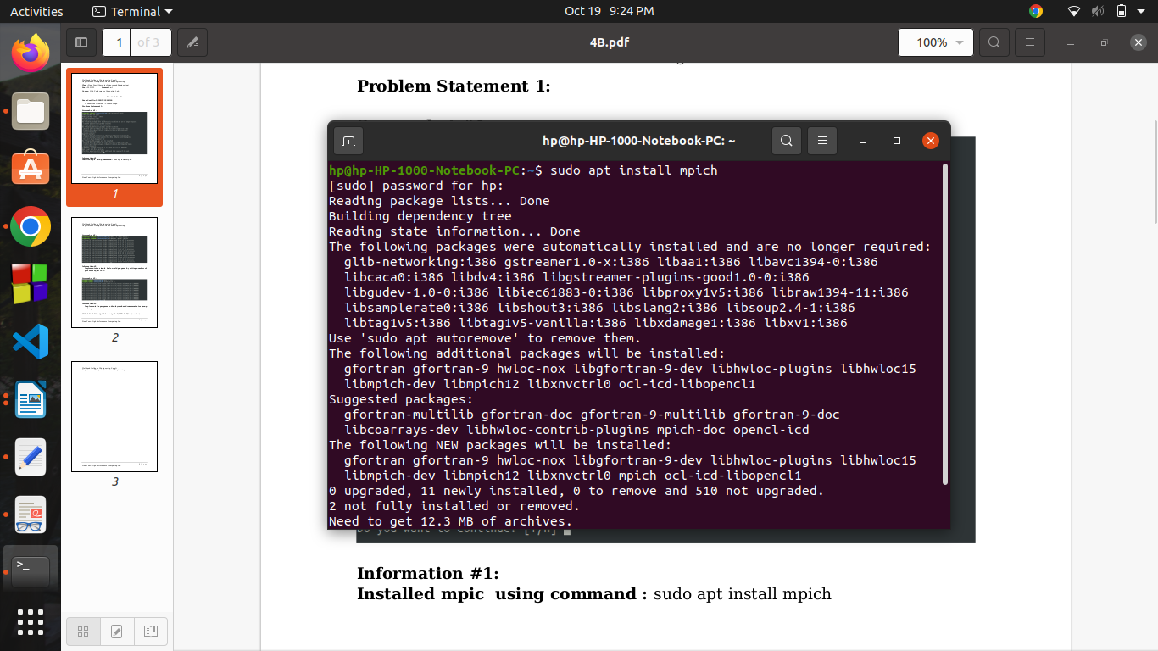

**Q1: Implement a simple hello world program by setting number of processes equal to 10.**

code:

#include <mpi.h>

#include <stdio.h>

int main( int argc, char *argv[] )

{

int rank, size;

MPI_Init( &argc, &argv );

MPI_Comm_rank( MPI_COMM_WORLD, &rank );

MPI_Comm_size( MPI_COMM_WORLD, &size );

char processor_name[MPI_MAX_PROCESSOR_NAME];

int name_len;

MPI_Get_processor_name(processor_name,&name_len);

printf( "Hello world from processor %s,rank %d out of %d processes \n",processor_name, rank, size );

MPI_Finalize();

return 0;

}

output:

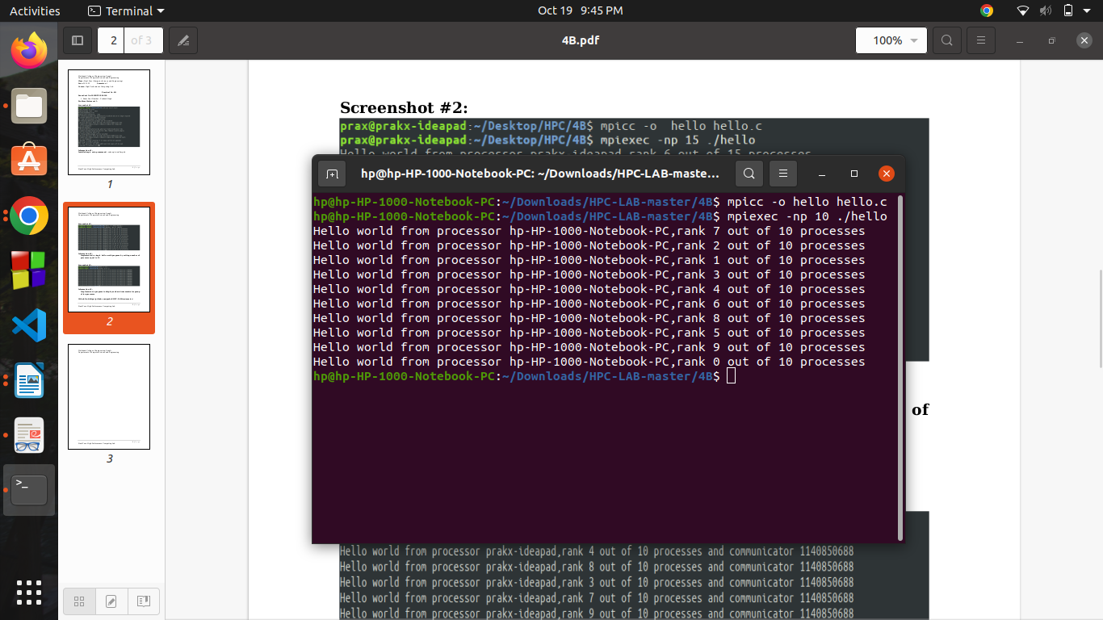

**Q2. Implement a program to display rank and communicator group of five processes.**

Code:

#include <mpi.h>

#include <stdio.h>

int main( int argc, char *argv[] )

{

int rank, size;

MPI_Init( &argc, &argv );

MPI_Comm_rank( MPI_COMM_WORLD, &rank );

MPI_Comm_size( MPI_COMM_WORLD, &size );

char processor_name[MPI_MAX_PROCESSOR_NAME];

int name_len;

MPI_Get_processor_name(processor_name,&name_len);

printf( "Hello world from processor %s,rank %d out of %d processes and communicator %d \n",processor_name, rank, size,MPI_COMM_WORLD);

MPI_Finalize();

return 0;

}

output:

